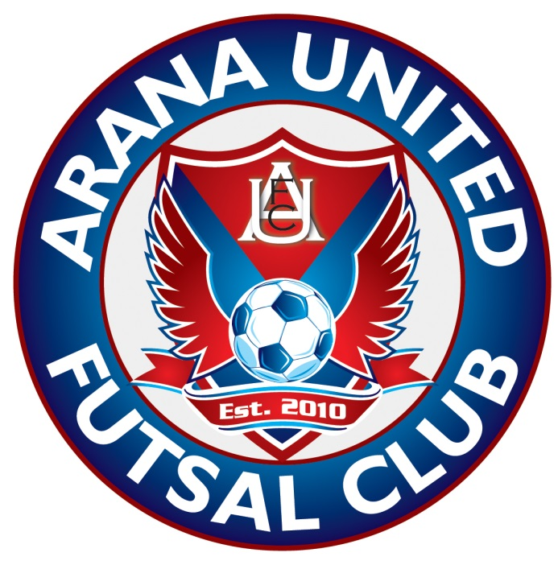
Arana United Futsal Club Inc.
Club Rules
Playing Requirements
- Players must wear matching team jerseys
- Players must wear appropriate footwear
- Players must wear shin pads
- Teams must be ready to start play at game kick-off time
- Players, team officials and spectators must adhere to the FFA code of conduct and competition rules at all times
- Players must produce proof of registration if required
- Players must produce proof of age if required
- A team match sheet needs to be completed and submitted with match fee prior to each game.
Arana United Futsal Club Copetition Rules (Read in conjunction with FIFA Futsal Rules)
- 5 players per team on the court (4 players, 1 goalkeeper)
- 20 minutes each half
- Sideline restart is kick in
- Goal clearance restart is with the ball in keepers hands
- Interchange rule – substitute must not enter field of play until substituted player exits
- Goalkeeper can throw and kick over half way on the full
- Appropriate footwear must be worn
- Two touch rule applies when goalkeeper has possession
- No time outs
- 5 team foul rule applies
- Players must show proof of registration if required
- Shin pads and long socks must be worn
BY-LAWS
1. Organisers
Arana United Futsal Club Inc.
Hills District PYC, Everton Hills, Queensland 4055
Ph: 0428235870
Email: info@aranaunitedfutsal.com
Web: www.aranaunitedfutsal.com
2. Preamble
The competitions are open to all players (male and female). All players must be registered with Football Queensland to be eligible to participate in club competitions. Registered players are also eligible to participate in Football Queensland State Championships and Premier League competitions, along with Football Federation Australia National Championship events. Club matches will be conducted and governed by FIFA Futsal Laws of the Game 2010. Arana United Futsal Club is affiliated to Football Queensland, Football Federation Australia and FIFA.
3. Venues
Hills District PCYC, Olearia Street, Everton Hills
Ferny Grove State High School
4. Cost and Registration
• Sign-on fees are $80 per player (juniors) and $90 (seniors). This includes Football Queensland Registration, PCYC membership (Hills District PCYC) and club development levy. Fees are non-refundable once a player plays their first game.
• Each team is required to pay $48 prior to each game played. Teams may also be required to pay a nomination fee of $48. All players MUST be registered before taking the field of play.
5. Insurance
• Registration fees includes Football Queensland registration and PCYC membership which includes insurance.
• If a player is seriously injured, they must fill out an incident report form on the day of the accident occurring.
6. Eligibility
• All players must be registered.
• Playing a non-registered player will result in the team losing the match 6-0.
7. Age groups
Will be determined on year of birth. Make up of competitions may be determined by player numbers in respective age groups.
8. List of Players
• Each team is entitled to list ten (10) players for each game.
• The players on the team sheets must be identical to those on the registration form.
9. Competition Structure
All fixtures, results and points tables will be available on the respective web site. Any changes will be posted on the web site, facebook page and an email or SMS may be sent to the team managers. Competitions will be structured depending on team nomination numbers. The top four (4) teams will play in the Championship Semi Finals with the two winners progressing to the Championship final. Premiers are the team which concluded the preliminary rounds in first (1st) position. Champions are the team that win the Championship Grand Final.
10. Duration of Matches
• Each match will comprise of two (2) x twenty (20) minute halves with a one (2) minutes half-time break.
• The game will start on time. The timekeeper will start the clock at the scheduled time of kick off regardless if teams are ready to play or not. If teams are not ready to play within five (5) minutes of the official kick off time, the match will be deemed a forfeit and the result will be a 6-0 win to the opponent.
• There will be no time outs and the clock will run for the duration of each half.
11. Match Balls
Under 6 yrs to Under 12 yrs will play with a size 3 match ball. Under 13yrs and above will play with a size 4 match ball. All balls will be supplied by Arana United Futsal Club.
12. Variation to FIFA Laws of the Game
• The ball size will vary depending on age groups (FIFA Law #2). Under 6yrs to Under 12yrs will play with a size 3 match ball. Under 13yrs and above will play with a size 4 match ball.
• There will be no time outs. (FIFA Law #7).
• The clock will run for its entire duration of each half. (FIFA Law #7).
• The FIFA Laws of the Game will be applied.
13. Competition Rules
(a). Players Equipment
• The basic compulsory equipment shall consist of an identical jersey or shirt, shorts, socks, shin pads and footwear.
• Each team strip (shirts, shorts and socks) shall be identical in colour, design and style.
• Players shall not wear anything that is considered dangerous to another player.
• Shin pads shall be entirely covered by socks, and shall be made of a suitable material to afford reasonable protection to the user.
• Goalkeepers shall wear colours that distinguish them from other players and from the referee.
• The player’s shirts shall be numbered with each player in the same team having a different number. The colour of the number shall contrast with the colour of the shirt.
• Only Futsal shoes and sneakers can be worn – no soccer boots.
• The club representative shall reserve the right to reject any uniform if considered inappropriate or undesirable. No appeal will be considered.
• Where there is a clash of colours, the home team shall change to an alternate strip. The home team is the first team mentioned on the team sheet and fixture list. The club will have bibs available.
(b). Officials
• The club will provide qualified referees to officiate at all matches.
(c). Match Score Sheets
• The match team sheet shall be completed for each game and submitted to the official desk ten (10) minutes prior to the kick off time.
• Players must be on court ready to start at the scheduled kick off time.
• If there is not three (3) players in a team to start a game after five (5) minutes of the scheduled kick off time, the match will be deemed a forfeit and the result will be a 6-0 win to the opponent. The game fees for both teams are payable by the forfeiting team.
• Players can only register with one (1) team in a particular competition for the duration of the season.
• Only players nominated on the registration forms can appear on match team sheets.
• Players must compete in a minimum of five (5) competition matches to be eligible to take part in the finals series.
14. Disciplinary Cards
(a). Yellow Cards
• Any yellow cards issued will be recorded by the club representatives.
• Any player who accumulates three (3) yellow cards will be suspended for their next competition match. This is a cumulative total over the season.
• Should a player accumulate a further three (3) yellow cards in a season, the player will incur an automatic suspension of two (2) matches.
• If a player receives two (2) yellow cards in one (1) match, the player must leave the playing area and must not remain on the substitute’s bench. A player who receives two (2) yellow cards in one match will be banned from playing one (1) competition match.
• Disciplinary cards issued throughout the competition will continue into the finals series.
(b). Red Cards
• A player who receives a red card must leave the playing area and must not remain on the substitute’s bench.
• A player receiving a red card can be replaced by a substitute after two (2) minutes following the expulsion of that player unless a goal is scored by the opposition before the two (2) minutes has elapsed.
• A player receiving a red card will be banned from playing for two (2) competitions matches.
• The club reserves the right to ask a player sent from the field of play to face a Disciplinary Committee.
• A player has the right to appeal a decision made by the Disciplinary Committee.
15. Discipline
The club has a Zero Tolerance Policy. Any persons (team officials, players, spectators) who breach the code of conduct may be asked to leave the premises and the game shall not continue until the person has complied. Teams that field unregistered or suspended players will forfeit the matches the players participated in. The result will be recorded as a 6-0 win to the opposing team. There will be no refund of match fees.
16. Forfeits
Forfeits relate to the following;
• Teams that can’t produce three (3) registered players on the field of play ready to play at the scheduled kick off time.
• Teams that play unregistered or suspended players.
Teams forfeiting a match will lose the game 6-0. There will be no refund of fees if a match is forfeited and the forfeiting team will be required to pay match fees for both teams.
TEAMS MUST PROVIDE 48 HRS NOTICE THAT THEY INTEND TO FORFEIT TO AVOID HAVING TO PAY FEES.
16(a). Borrowing of players
FIFA Futsal Law 3 - 'The Number of Players'
'A match may not start if either team consists of fewer than three players. The match is abandoned if one of the teams has fewer than three players on the pitch.'
Club by law - If the opposition team official/captain is agreeable, teams may borrow registered players from other teams in order to field a team of five players maximum (no reserves). A player can only play as a substitute for another team on 2 occasions (i.e. max 2 occasions per team). The spirit of this by-law is to provide sufficient flexibility to support 'fair play' principals, to maximise player enjoyment and to give all players the opportunity to participate in games (avoiding forfeits). This by-lay implies, however, that players play regularly for one designated team only. Suitability of borrowed players (age / skill level) will be at the discretion of the club official. Teams cannot borrow players in finals.
17. Match Points
In accordance with the FIFA Laws of the game, the points shall be;
(a) 3 points for a win;
(b) 1 points for a draw;
(c) 0 points for a loss.
18. Finals Series
• To be eligible for the Finals Series, players must be registered and played a minimum of five (5) matches throughout the season.
• If at the conclusion of the preliminary rounds, teams are equal on points, the following qualifications apply to determine team places;
(a) goal difference;
(b) head to head result;
(c) Fair Play Award (least number of disciplinary cards);
(d) number of goals scored;
• If at the conclusion of normal time, the scores are level, an additional two (2) periods of five (5) minutes each will be played.
• If necessary and the scores remain level after extra time, golden goal will be applied.

